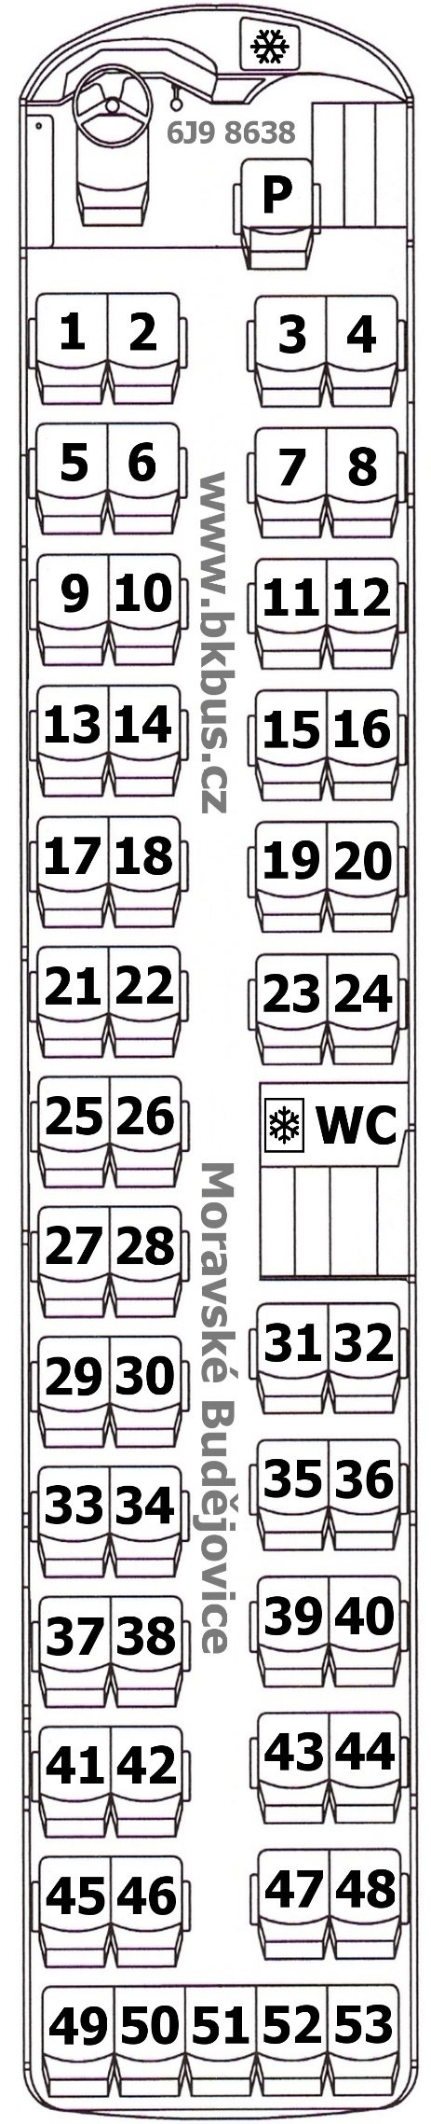

1__________________
2__________________
3__________________
4__________________
5__________________
6__________________
7__________________
8__________________
9__________________
10_________________
11_________________
12_________________
13_________________
14_________________
15_________________
16_________________
17_________________
18_________________
19_________________
20_________________
21_________________
22_________________
23_________________
24_________________
25_________________
26_________________
27_________________
28_________________
29_________________
30_________________
31_________________
32_________________
33_________________
34_________________
35_________________
36_________________
37_________________
38_________________
39_________________
40_________________
41_________________
42_________________
43_________________
44_________________
45_________________
46_________________
47_________________
48_________________
49_________________
50_________________
51_________________
52_________________
53_________________
P _________________

